

Faculty of Applied Sciences  
Bachelor of Science in Computing

**COMP490 Final Year Project  
Project Proposal**Academic Year 2022/23

|  |  |
| --- | --- |
| Your project title | |
|  |  |
| Project number: | Your project number |
| Student ID: | P1908404 |
| Student Name: | Your name |
|  |  |
| Supervisor: | Your supervisor |
| Assessor: | Your assessor |
|  |  |
| Submission Date: | Submission date |

Table of Contents

1 Project Description 2

2 Summary of Related Work and Key References 3

3 Project Work Plan 4

4 Risk Assessment 5

References 6

# Project Description

Video games have been very popular with teenagers since their occurred. Today, with video games’ developing, they involve more and more concepts and aspects about our life, and their themes have gradually become more and more profound and different from the initial "just for fun". Like movies and plays, many people are now calling games as "the ninth art."

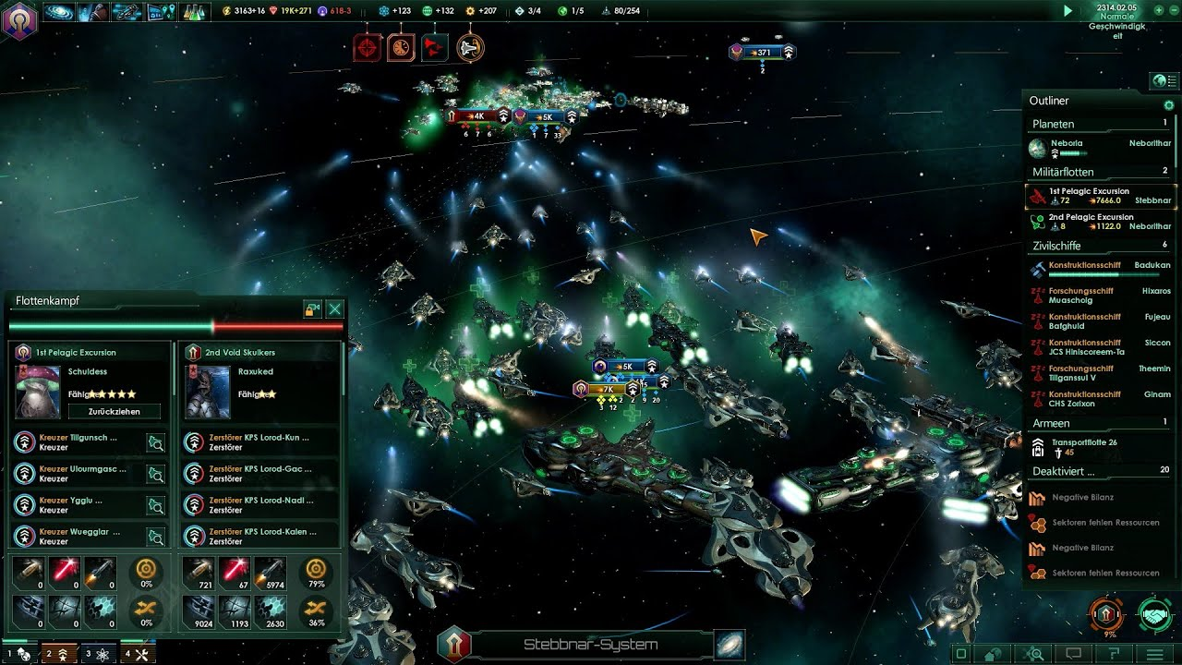

Stellaris, a large-scale strategy game with the theme of space exploration.

However, for adults, as the pace of society accelerates, they have to devote more time to their work or study, and the time for them to play video games is often fragmented. This makes it difficult for them to play games which requires time to practice their gaming skills, or because the gaps are too long, they tend to forget the stories of games with large-scale continuous plots. For these reasons, when many adults want to play games in their free time, they have to face these frustrating facts, so it's hard for them to enjoy gaming in this situation.

So, that is why it is necessary to design some casual mini-games for adults. They often do not have obscure plots, do not require too much learning time cost, and allow players to pass a level within a few minutes to ten minutes, so players can relax and enjoy a sense of accomplishment quickly. Also, since these types of games tend to be played in fragmented times, they are best played on mobile platforms as well, such as mobile phones or game consoles.

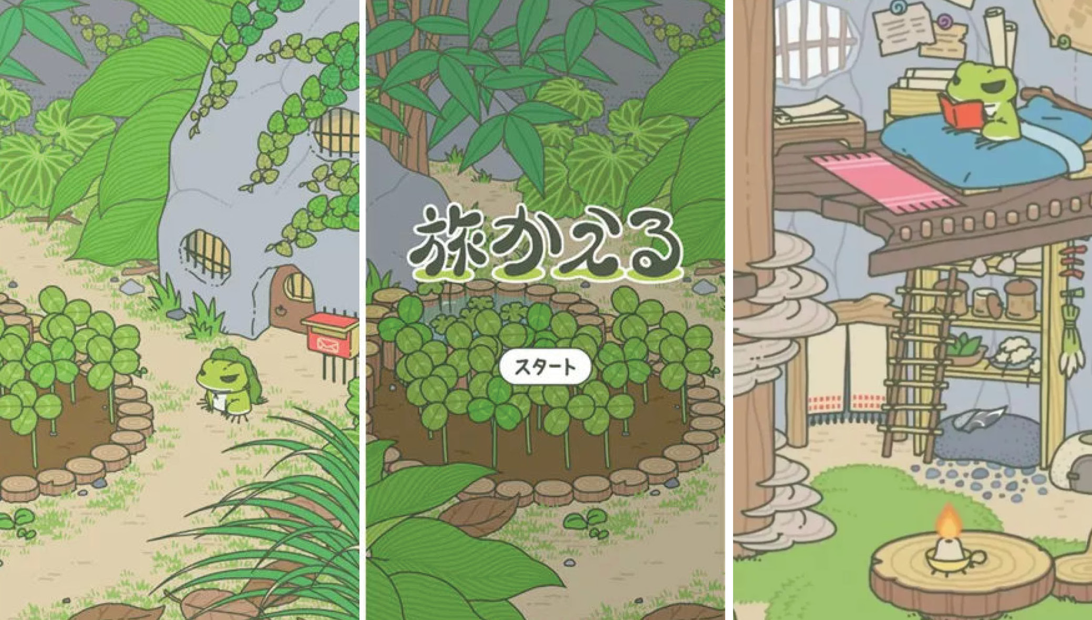

Travel Frog, a mobile casual game, players don’t need to do complex operation to play it.

This project aims to achieve:

* Design the whole structure of the game
* Design the game logic and game background
* Create the video and sound effects that are used in the game
* Develop the game interface
* Develop the different game level
* Develop the game interaction system
* Write the scripts which implement specific game functionality.

The project’s outcome should be a indie lightweight casual 2D game with multiple levels, which allowing players to enjoy the sense of achievement brought by completing levels while solving puzzles.

I chose to use the Unity engine to develop this project, so a good grasp of it is necessary. In addition, since Unity requires the game script to be written in C#, and I don't have much experience in using the C# language, I believe this will be a challenge for my final year project.

# Summary of Related Work and Key References

This project will be built with Unity game engine. Unity is a cross-platform game engine initially released by Unity Technologies, in 2005. The focus of Unity lies in the development of both 2D and 3D games and interactive content[1]. In addition, Unity has very convenient packaging built-in exporting tools, which can easily deploy the completed game project on a variety of operating systems. There are many famous games developed with Unity now, such as *Hearthstone: Heroes of Warcraft* and *Temple Run.*

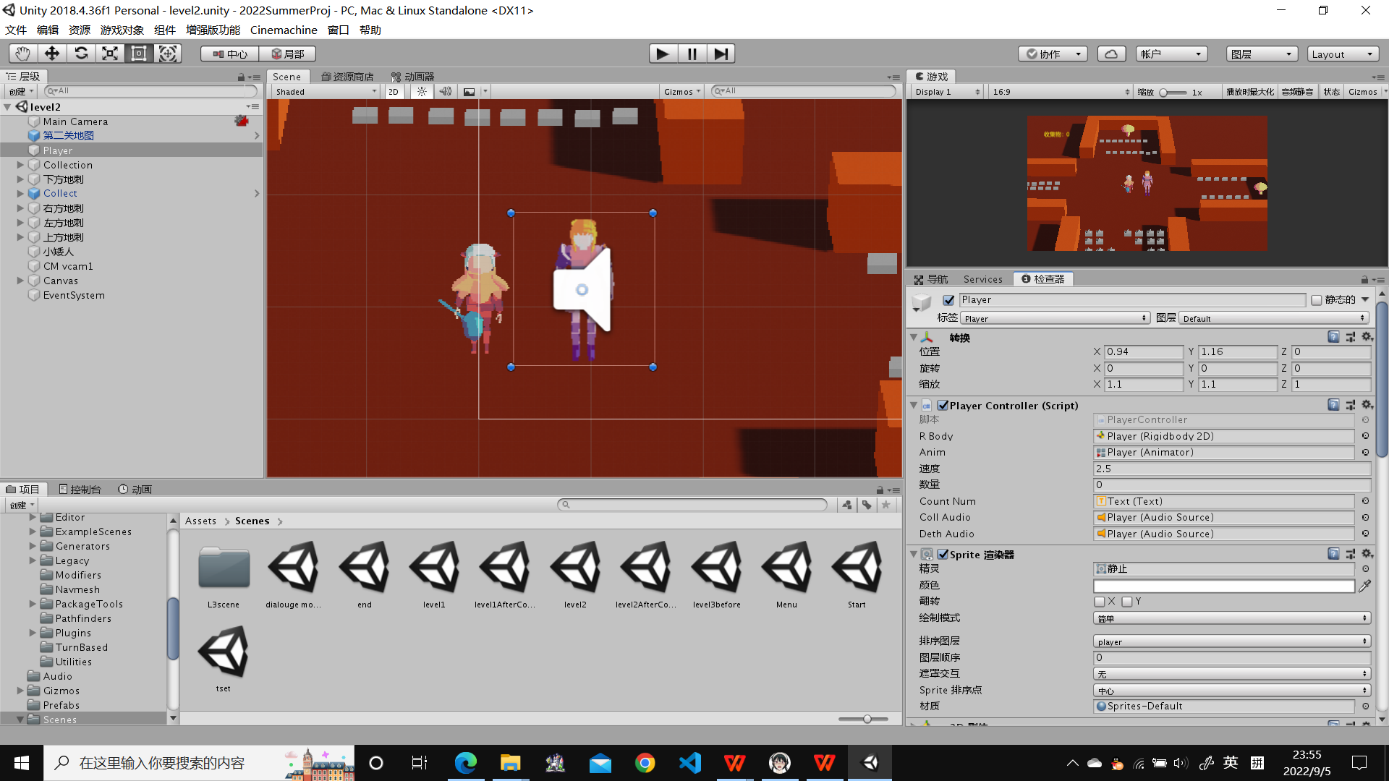

The development interface of Unity

Also, there is other different engines for game developing. Such as Unreal, which is a famous and handy engine in developing, too. But eventually the Unity engine is chosen. Why? Firstly, Unity was built with mobile apps in mind, so development for these devices is very streamlined. On the other hand, Unreal is developed for AAA titles and those geared toward high-end devices. As a indie game with limited processing requirements and developer, it is clearly that using Unreal is too cumbersome. What’s more, for individual developers and small enterprises, Unity has a special charge plan for them. They are free to use Unity to develop their projects, then publish it on open platforms with no extra fees. However, although Unreal engine can be used freely, once the developer decide to publish the game as a premium one, then the 5% of earnings for Unreal’s company is necessary. In the long run, Unity engine with streamlined functions and lower individual cost seems to be a better choice[2].

# Project Work Plan

Sem1:

|  |  |  |
| --- | --- | --- |
| Name | Duration | Start/End Date |
| Project allocation | 2 weeks | 8.19-9.1 |
| Project Proposal and ethics form submission | 1 week | 9.2-9.9 |
| Supervisors return comments on Proposal | 1 week | 9.10-9.16 |
| Weekly updates in Weekly Status Report | 10 weeks | 9.10-11.18 |
| Gantt chart submission | 2 weeks | 9.10-9.23 |
| Progress Report submission | 8 weeks | 9.10-11.5 |
| Progress Presentation | 1 week | 11.6-11.11 |
| Supervisors and assessors return comments on Progress Report | 2 weeks | 11.12-11.25 |

Sem2:

|  |  |  |
| --- | --- | --- |
| Name | Duration | Start/End Date |
| Weekly updates in Weekly Status Report | 13 weeks | 1.5-4.5 |
| Implementation mostly done | 6 weeks | 1.5-2.15 |
| Final Report draft submission | 8 weeks | 1.5-3.1 |
| Supervisors return comments on Final Report draft | 1 week | 3.2-3.8 |
| Poster submission | 1 week | 3.9-3.15 |
| Final Presentation, Poster session Final Report submission | 3 weeks | 3.16-4.6 |

# Risk Assessment

Risk1: Games made with Unity have a lower threshold for cracking, and users are more likely to develop plug-ins to cheat.

Risk2: If the developer changes the Unity versions during development, the project may not continue to be developed normally due to incompatibility between different versions.

References

[1]Unity - Introduction. (n.d.). Tutorialspoint.com. Retrieved September 3, 2022, from https://www.tutorialspoint.com/unity/unity_introduction.htm

[2] Omelchenko, S. (2021, April 13). Unity vs. Unreal: Choosing the best engine for 2022. Program-Ace. https://program-ace.com/blog/unity-vs-unreal/

[3] Omelchenko, S. (2021, April 13). Unity vs. Unreal: Choosing the best engine for 2022. Program-Ace. https://program-ace.com/blog/unity-vs-unreal/

[4] Georg Gottlob, Nicola Leone, and Francesco Scarcello. Hypertree decompositions and tractable queries. Journal of Computer and System Sciences, 64(3):579–627,May 2002.

[5] Georg Gottlob. Complexity results for nonmonotonic logics. Journal of Logic and Computation, 2(3):397–425, June 1992.

[6] Hector J. Levesque. Foundations of a functional approach to knowledge representation. Artificial Intelligence, 23(2):155–212, July 1984.

第二部分技术提及，只有unity？

引用需要标project list吗

需要侧重独立游戏吗？